Lab 14 – Terraform + Ansible
Student Name: Tooba Shafique
Registration no: 2023-BSE-065

📌 Task 0 – Lab Setup (Codespace & GH CLI)
Tasks
- Open GitHub Codespace
- Verify AWS CLI, Terraform, Ansible
- Verify AWS credentials
Screenshots
- task0_codespace_open.png
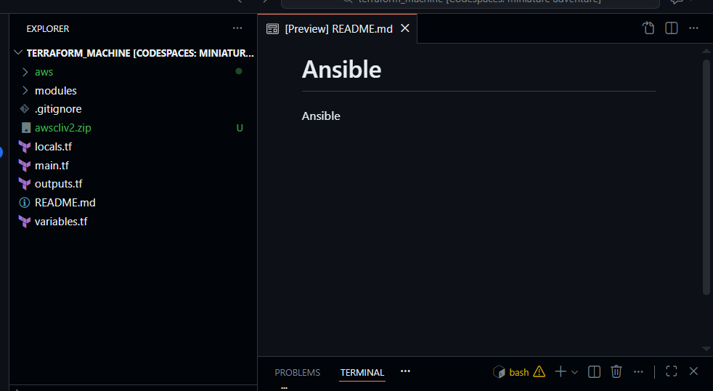
- task0_env_check.png
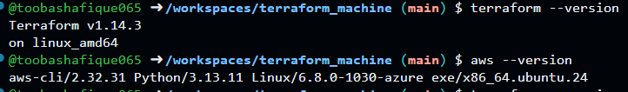
- task0_aws_config.png
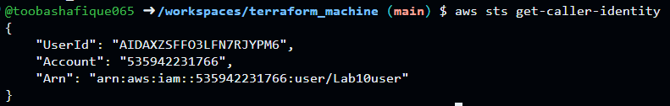

📌 Task 1 – Clone Terraform+Ansible Repo & Initial Terraform Apply
Tasks
- Clone Terraform repository
- Generate SSH key pair
- Create terraform.tfvars
- Initialize and apply Terraform (2 instances)
- Verify Terraform outputs
Screenshots
- task1_ssh_keygen_before.png
- task1_ssh_keygen.png
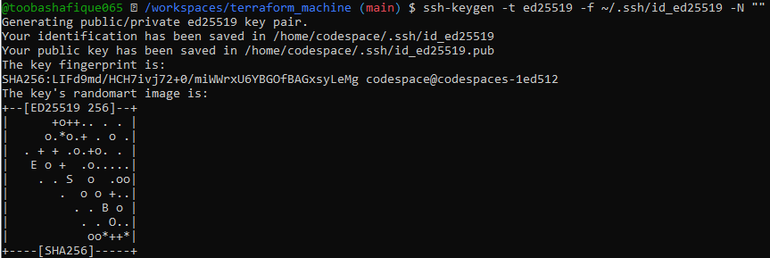
- task1_ssh_keygen_after.png
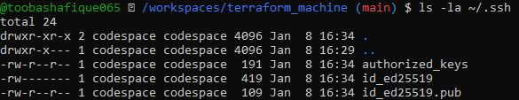
- task1_terraform_tfvars_created.png
- task1_terraform_tfvars.png
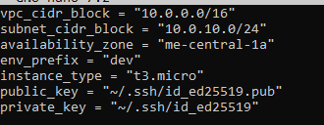
- task1_terraform_init.png
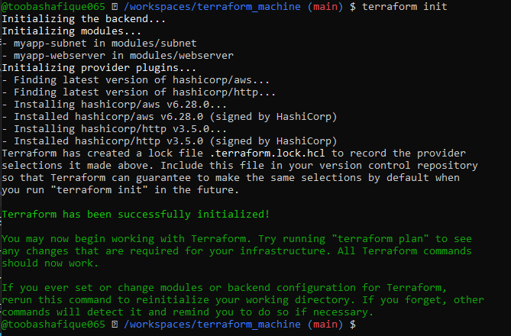
- task1_terraform_apply_2_instances.png
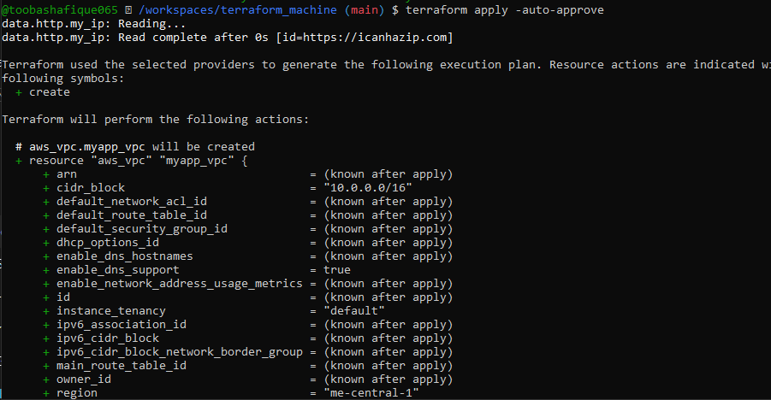
- task1_terraform_output_ips.png
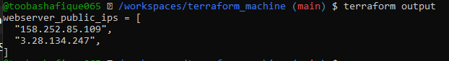

📌 Task 2 – Static Ansible Inventory (2 EC2 Instances)
Tasks
- Install Ansible
- Create static inventory file
- Test Ansible connectivity
Screenshots
- task2_ansible_install.png
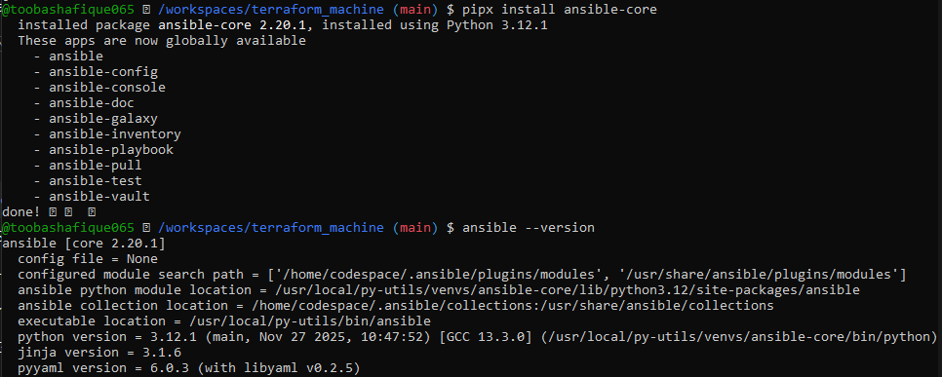
- task2_terraform_output_ips.png
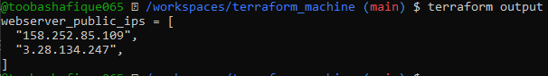
- task2_hosts_created.png
- task2_hosts_initial.png
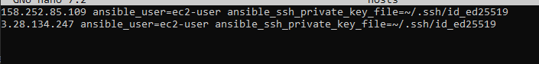
- task2_ansible_ping_initial.png
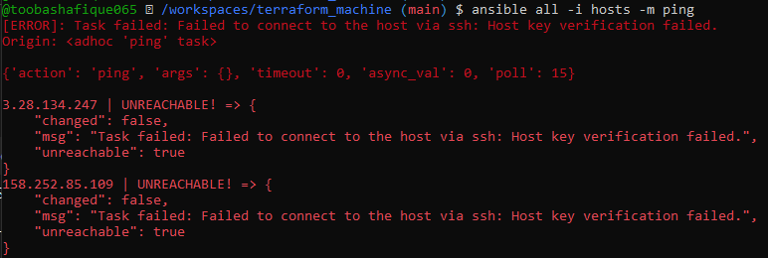
- task2_hosts_with_common_args.png
- task2_ansible_ping_success.png
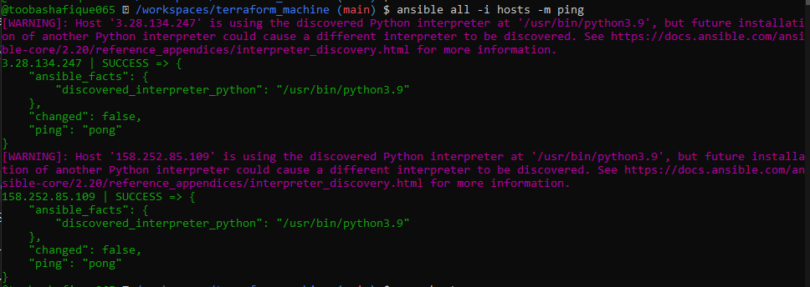

📌 Task 3 – Scale to 3 Instances & Group Inventory
Tasks
- Update Terraform count to 3
- Apply Terraform
- Create grouped Ansible inventory
- Test groups and individual hosts
Screenshots
- task3_main_tf_count_3.png
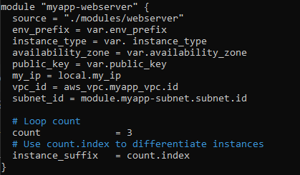
- task3_terraform_apply_3_instances.png
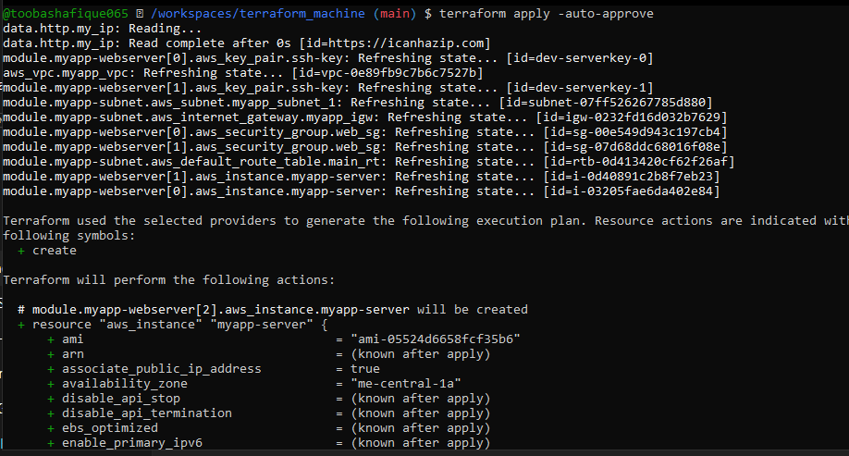
- task3_terraform_output_3_ips.png
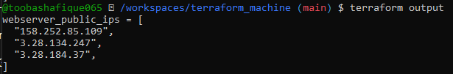
- task3_hosts_grouped.png
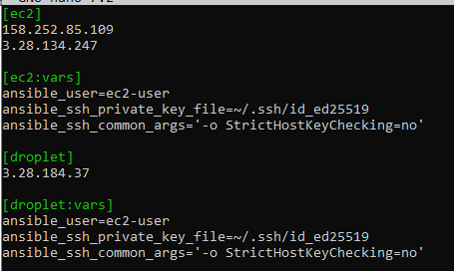
- task3_ansible_ec2_ping.png
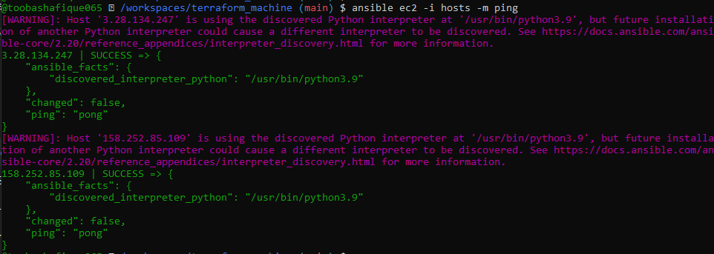
- task3_ansible_single_ip_ping.png
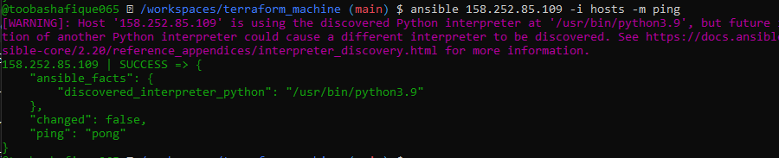
- task3_ansible_droplet_ping.png
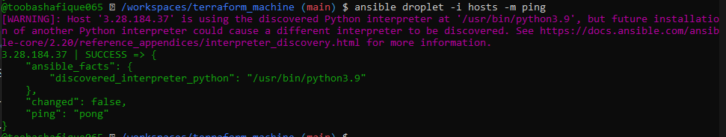
- task3_ansible_all_ping.png
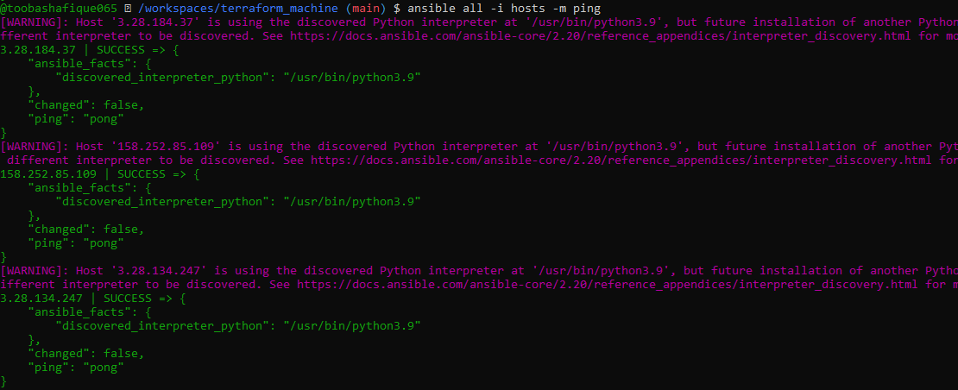

📌 Task 4 – Global Ansible Config & First Nginx Playbook
Tasks
- Create global ~/.ansible.cfg
- Remove SSH common args from hosts
- Create nginx playbook
- Deploy nginx on EC2 & droplet
Screenshots
- task4_global_ansible_cfg.png
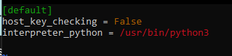
- task4_hosts_without_common_args.png
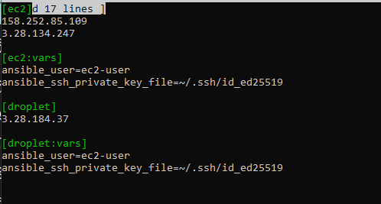
- task4_ansible_ping_after_cfg.png
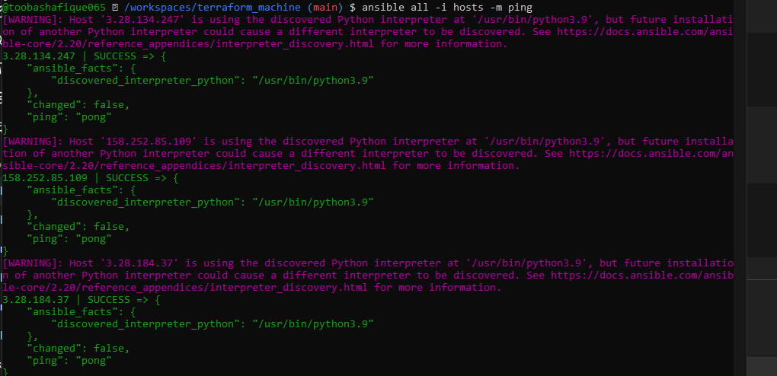
- task4_my_playbook_created.png
- task4_my_playbook_ec2.png
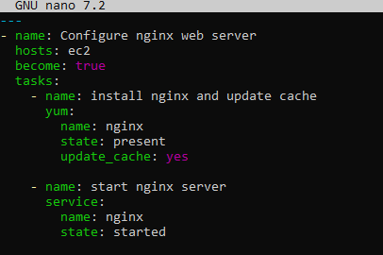
- task4_ansible_play_ec2.png
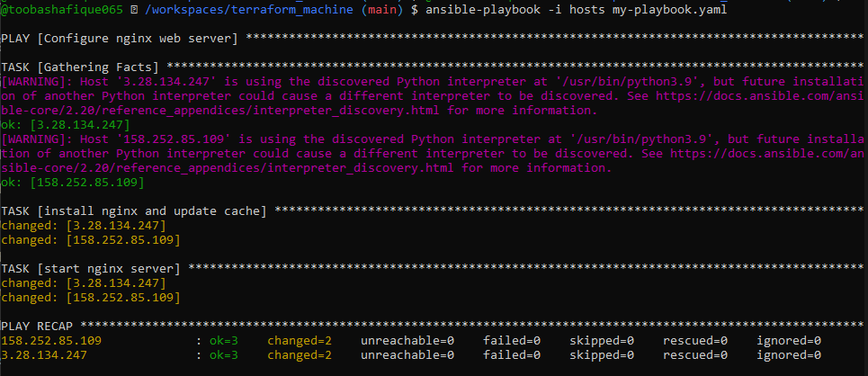
- task4_nginx_browser_ec2.png
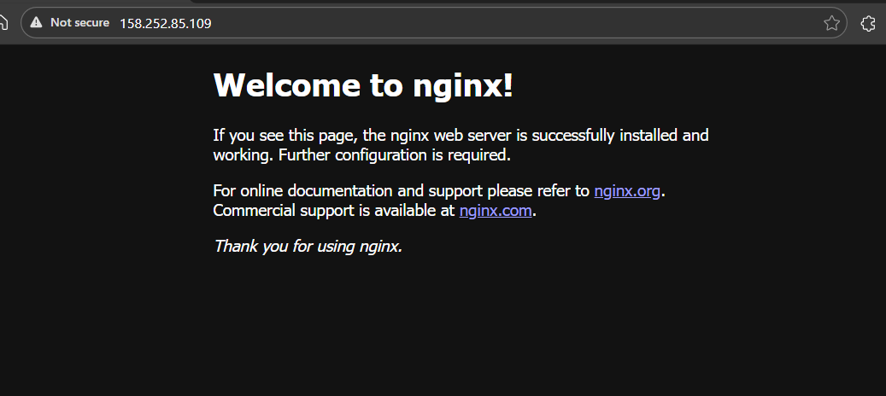
- task4_my_playbook_droplet.png
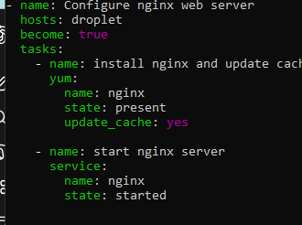
- task4_ansible_play_droplet.png
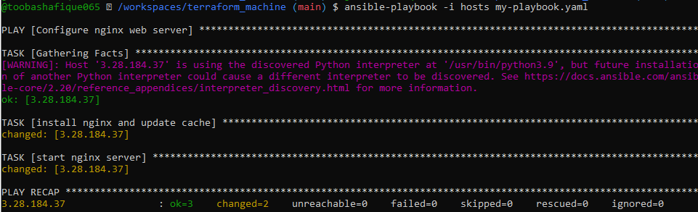
- task4_nginx_browser_droplet.png
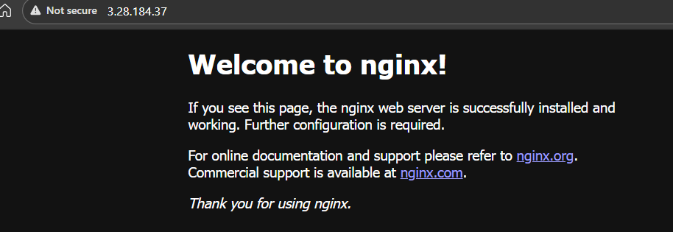

📌 Task 5 – Single Nginx Target & HTTPS Prerequisites
Tasks
- Create project-level ansible.cfg
- Reduce EC2 count to 1
- Configure nginx + openssl
Screenshots
- task5_project_ansible_cfg_created.png
- task5_project_ansible_cfg.png
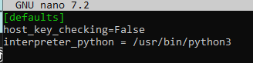
- task5_main_tf_count_1.png
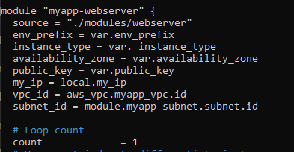
- task5_terraform_apply_one_instance.png
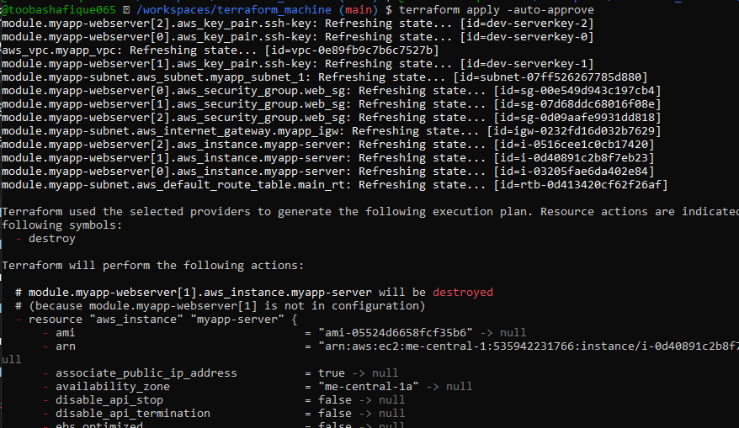
- task5_terraform_output_single_ip.png
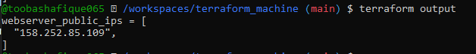
- task5_hosts_nginx_group.png
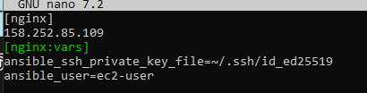
- task5_my_playbook_nginx_group.png
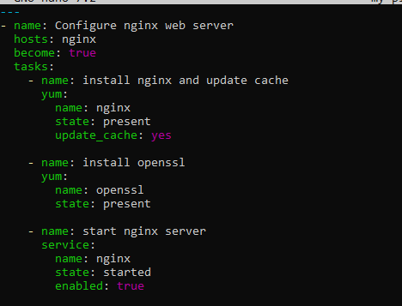
- task5_ansible_play_nginx_group.png
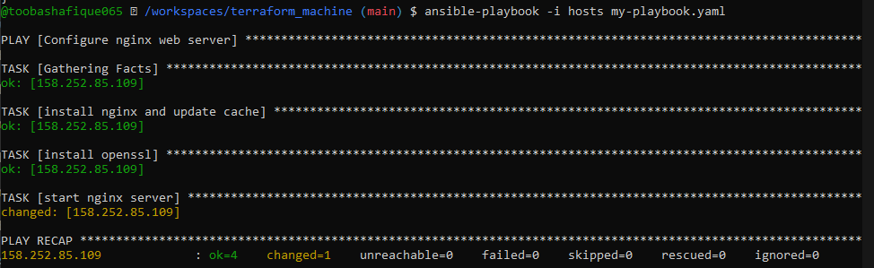
- task5_nginx_browser_single.png
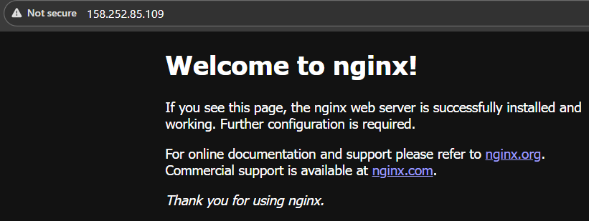

📌 Task 6 – Ansible Managed SSL Certificates
Tasks
- Generate IMDSv2 token
- Create self-signed SSL certificates
- Verify SSL files on EC2
Screenshots
- task6_my_playbook_ssl_section.png
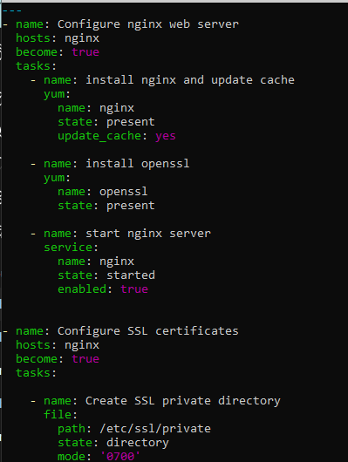
- task6_ansible_play_ssl.png
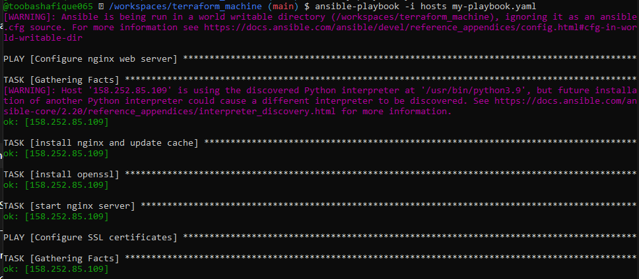
- task6_ssl_cert_file.png 158.252.85.109
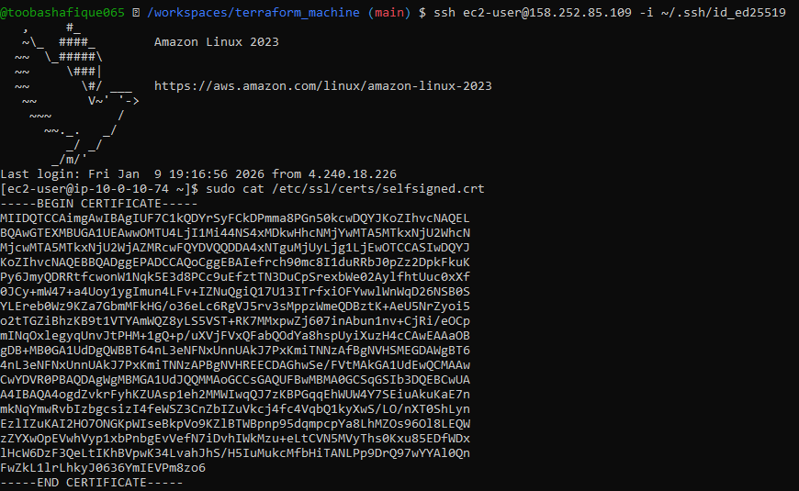
- task6_ssl_key_file.png
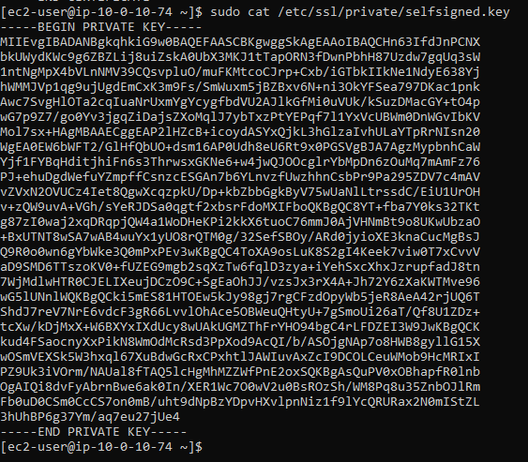

📌 Task 7 – PHP Frontend Deployment
Tasks
- Create PHP metadata page
- Create Nginx template
- Deploy PHP + HTTPS website
Screenshots
- task7_files_templates_created.png
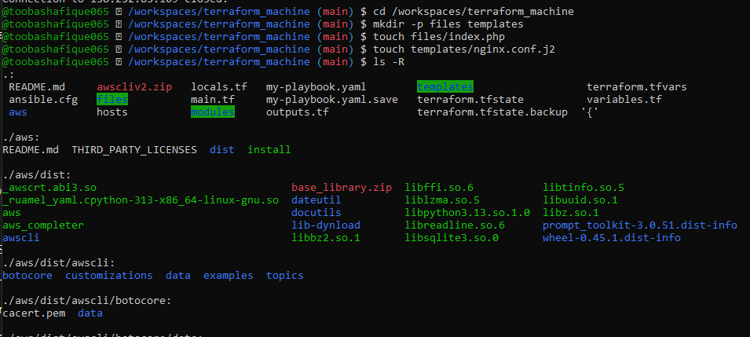
- task7_index_php_content.png
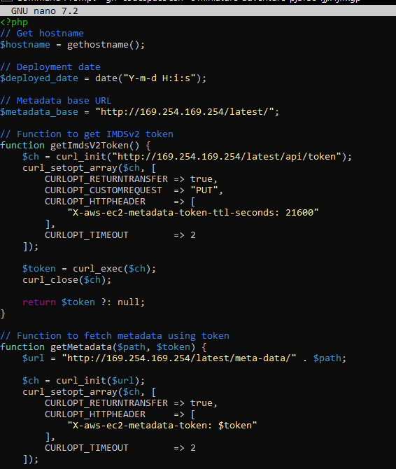
- task7_nginx_conf_template.png
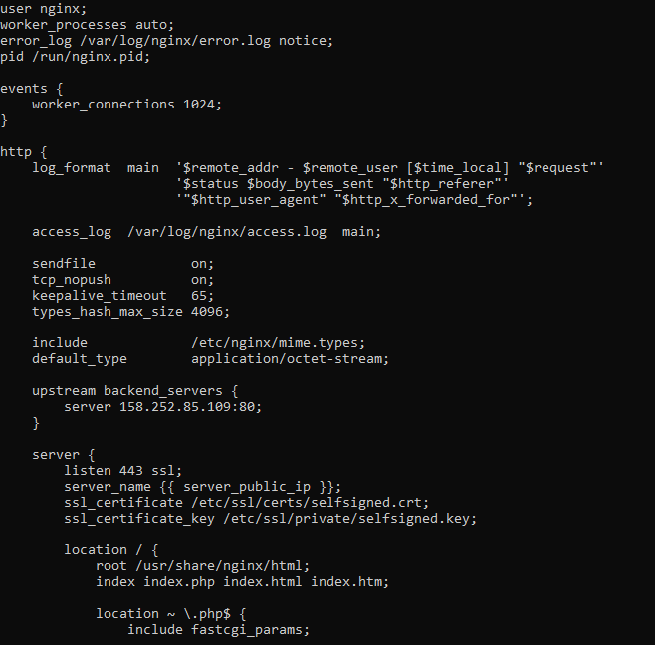
- task7_my_playbook_web_deploy.png
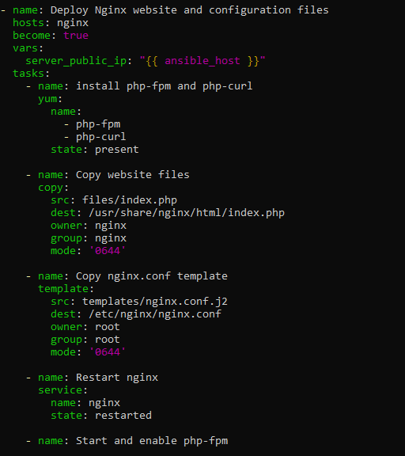
- task7_ansible_play_web_deploy.png
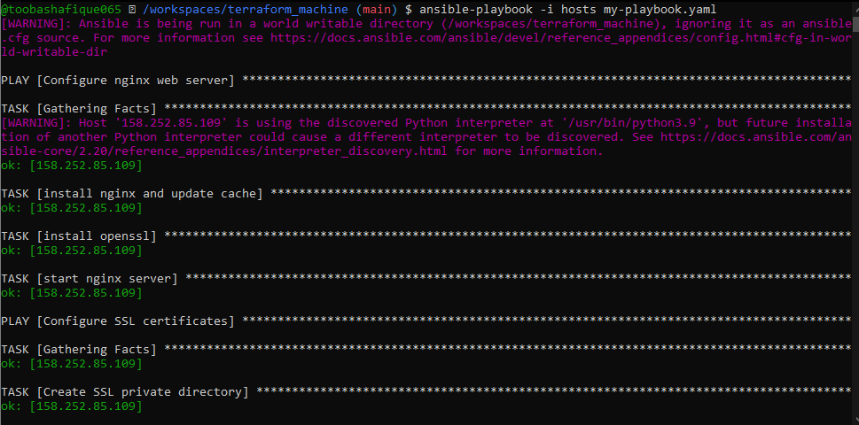
- task7_php_https_browser.png
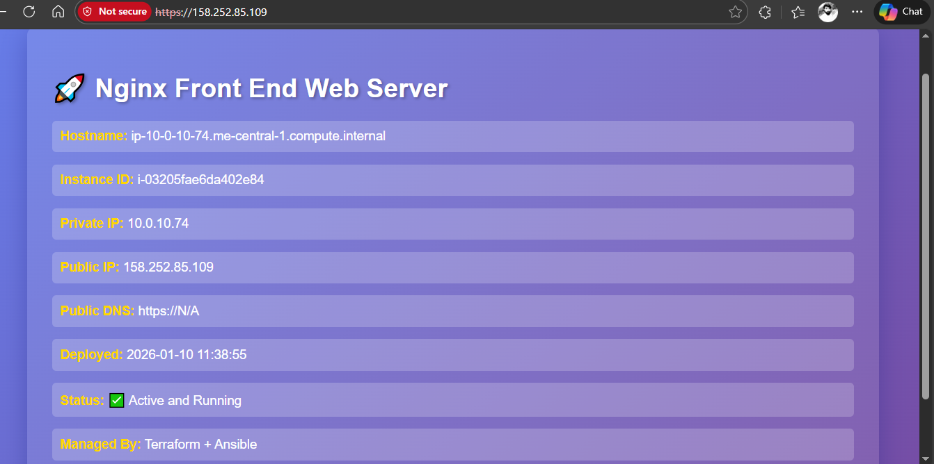

📌 Task 8 – Docker & Docker Compose via Ansible
Tasks
- Destroy old infra
- Create Docker EC2 instance
- Install Docker & Docker Compose
Screenshots
- task8_terraform_destroy_old.png
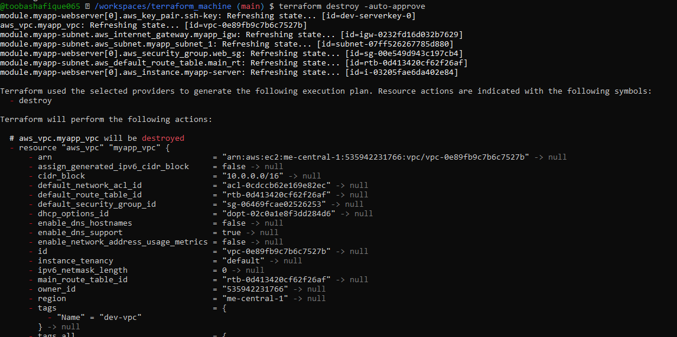
- task8_terraform_apply_docker_instance.png
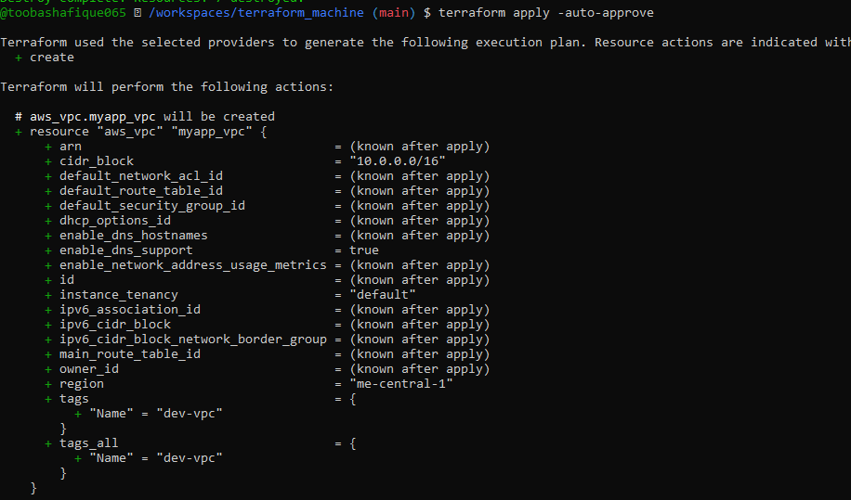
- task8_terraform_output_new_ip.png
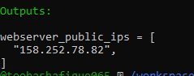
- task8_hosts_docker_servers.png
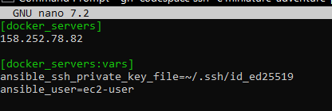
- task8_my_playbook_docker.png
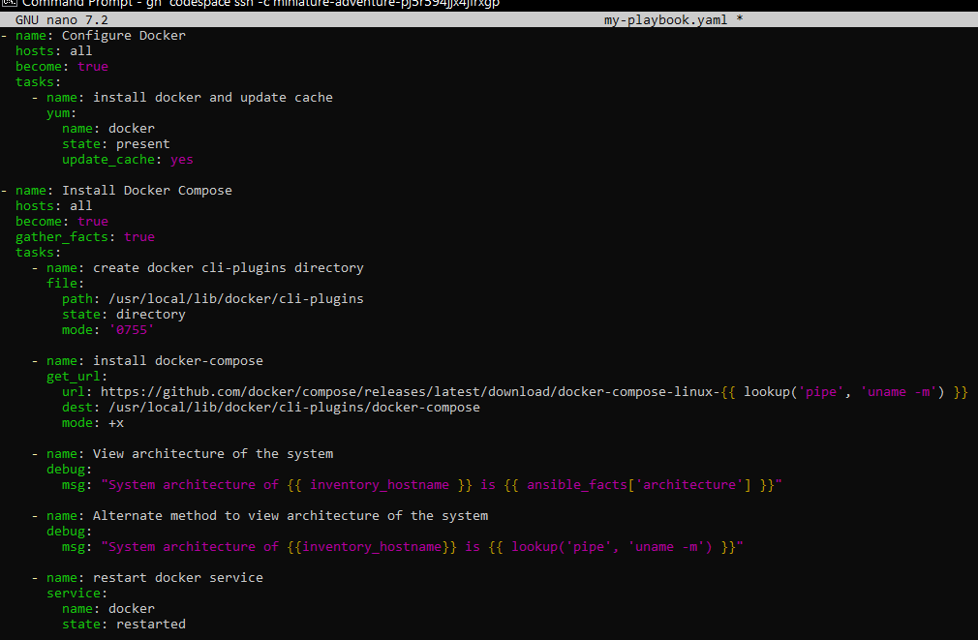
- task8_ansible_play_docker.png
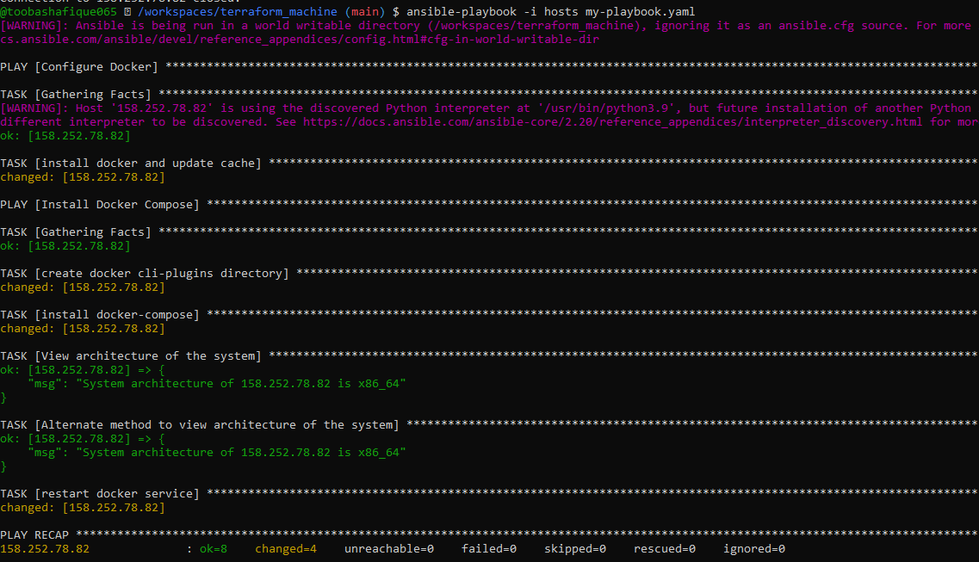
- task8_docker_ps_remote.png
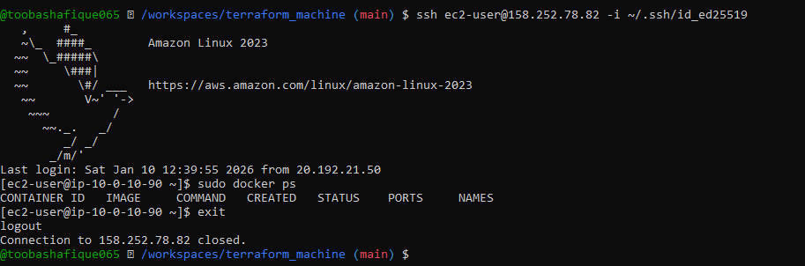

📌 Task 9 – Gitea Docker Stack & Security Group
Tasks
- Add user to docker group
- Deploy Gitea + Postgres
- Open port 3000
- Access Gitea UI
Screenshots
- task9_my_playbook_add_user_to_docker.png
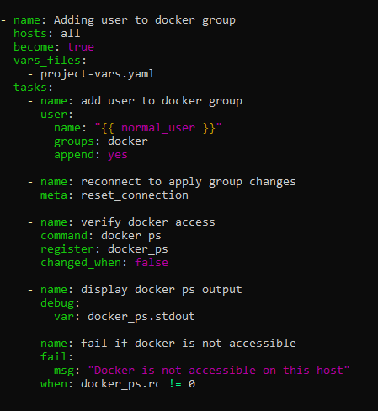
- task9_project_vars.png
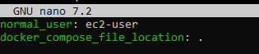
- task9_my_playbook_deploy_containers.png
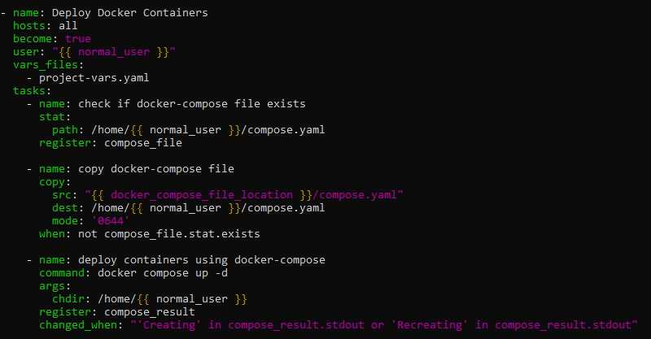
- task9_compose_yaml.png
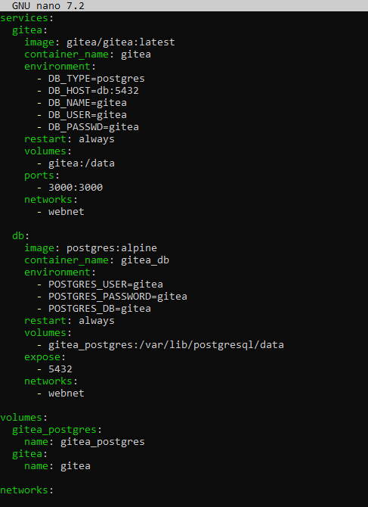
- task9_ansible_play_gitea.png
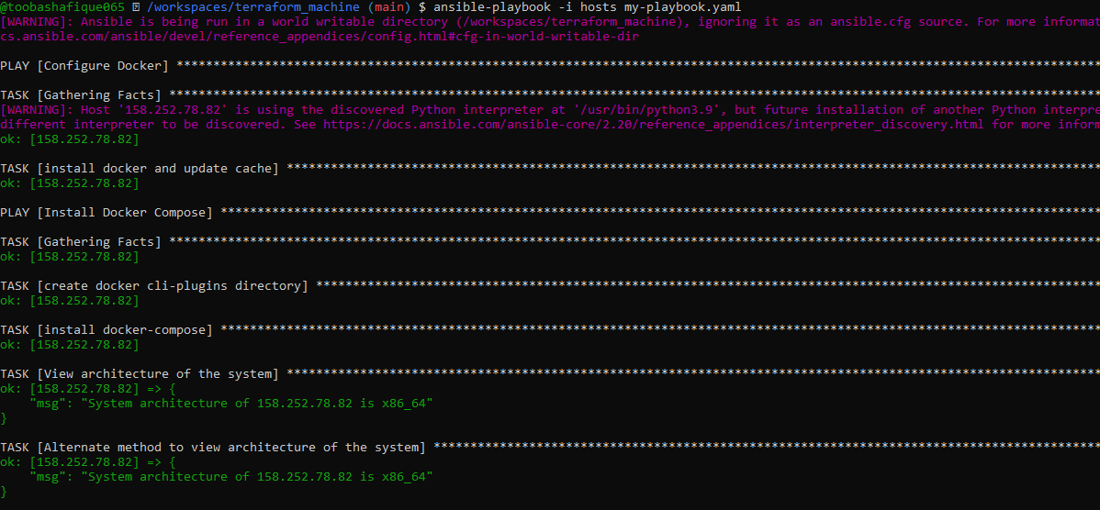
- task9_sg_ingress_3000.png
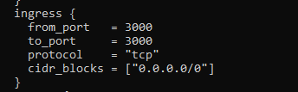
- task9_terraform_apply_sg_3000.png
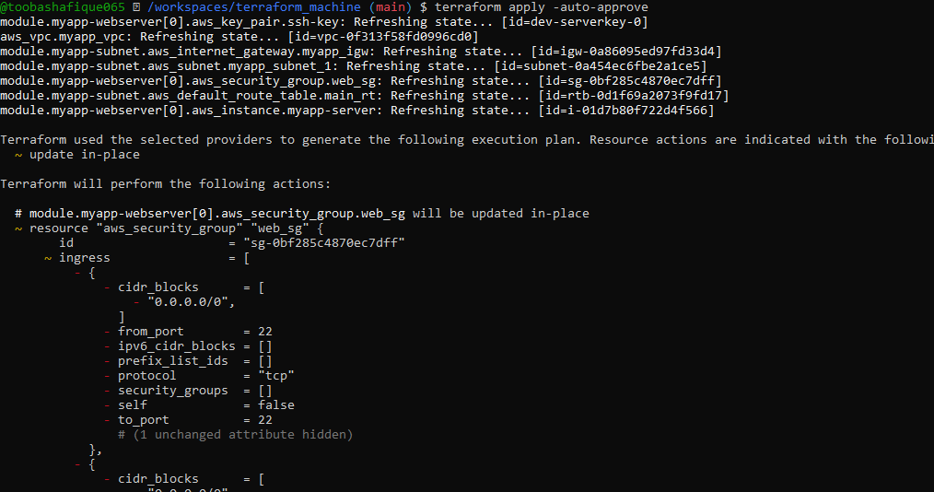
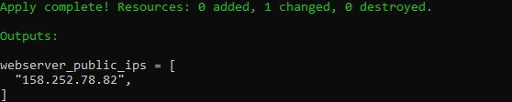
- task9_gitea_browser.png
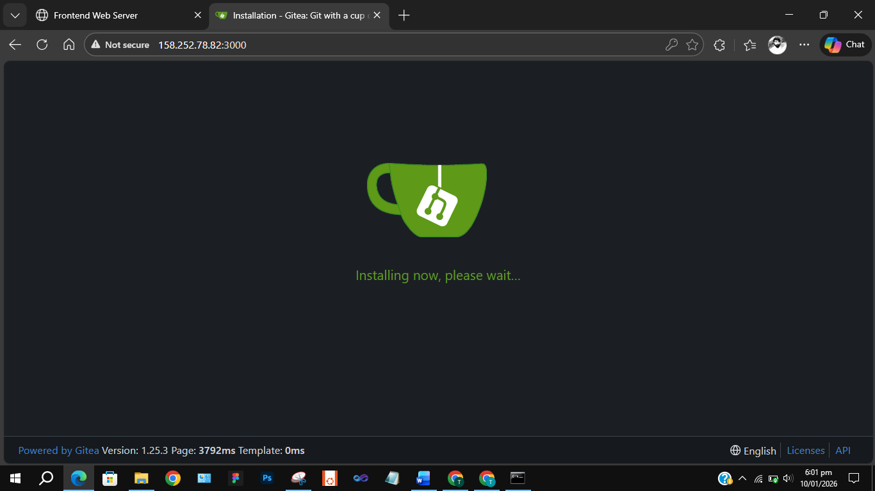
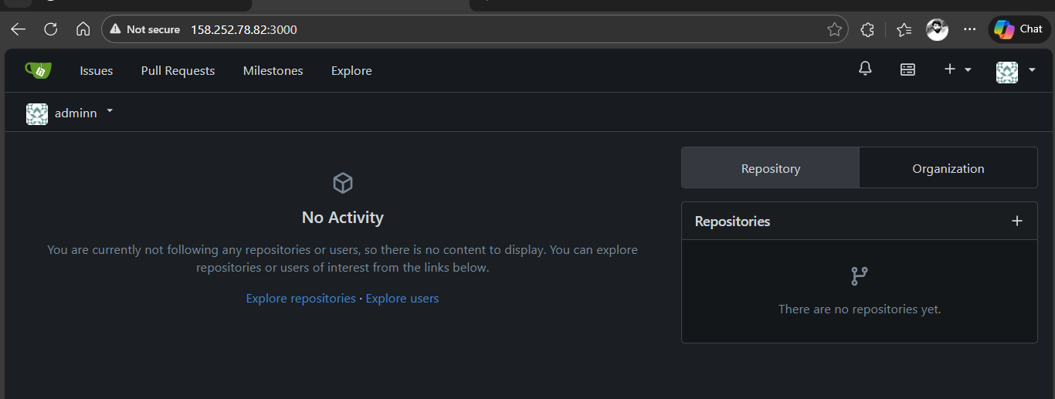

📌 Task 10 – Terraform + Ansible Automation (null_resource)
Tasks
- Add null_resource
- Trigger Ansible from Terraform
- Fix SSH readiness with wait task
Screenshots
- task10_null_resource_main_tf.png
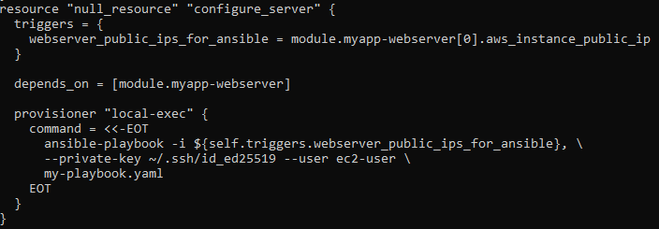
- task10_terraform_destroy_before_null.png
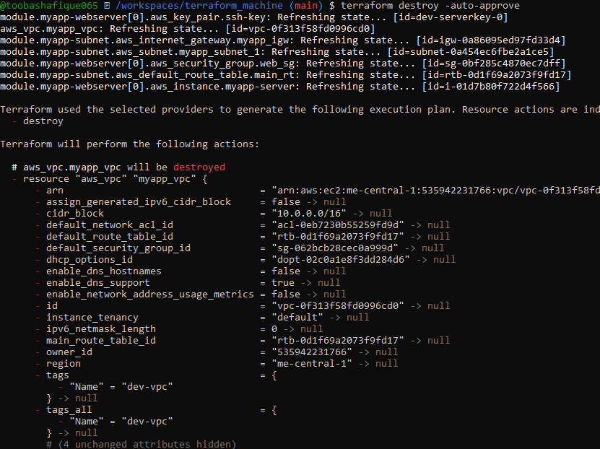
- task10_my_playbook_wait_for_ssh.png
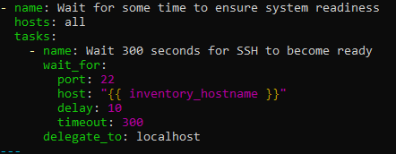
- task10_terraform_apply_after_wait.png
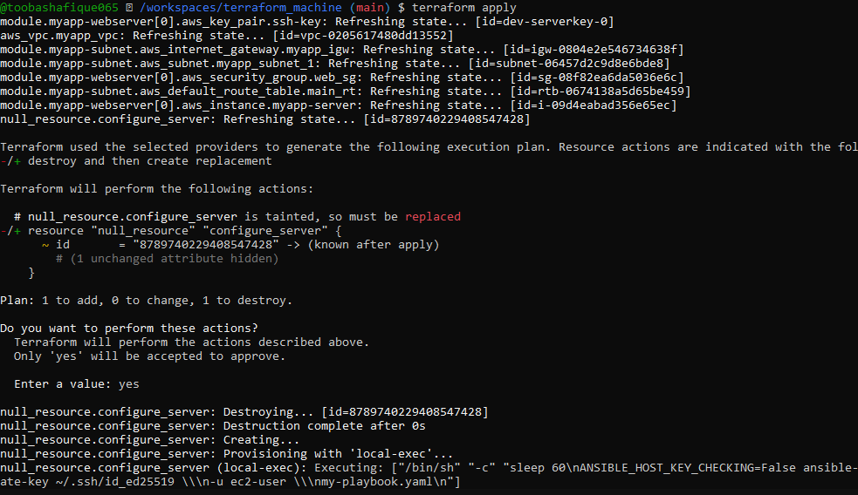
- task10_app_browser_post_null_resource.png
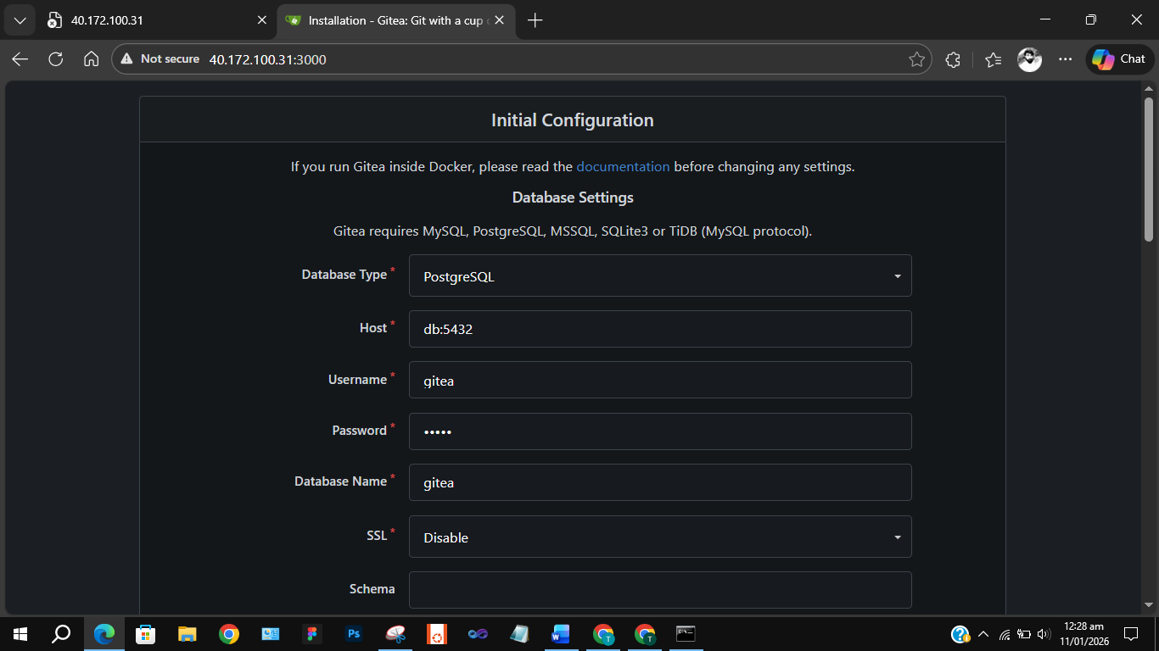
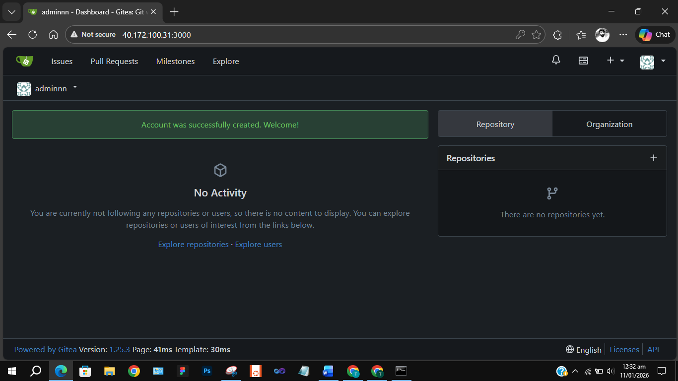

📌 Task 11 – Dynamic Inventory (aws_ec2 Plugin)
Tasks
- Configure aws_ec2 plugin
- Create dynamic inventory
- Deploy dev & prod EC2 instances
Screenshots
- task11_ansible_cfg_aws_ec2.png
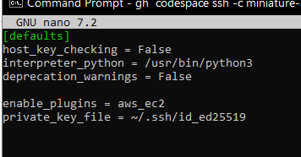
- task11_inventory_aws_ec2_created.png
- task11_inventory_aws_ec2_initial.png
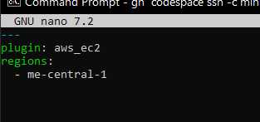
- task11_main_tf_dev_prod_modules.png
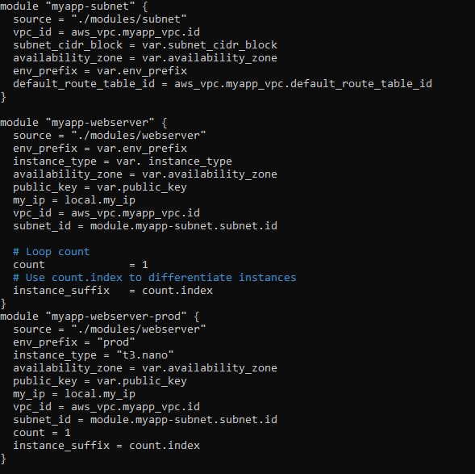
- task11_outputs_tf_dev_prod_ips.png
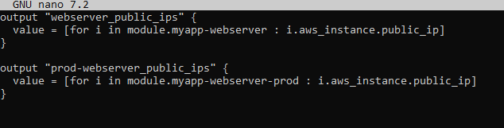
- task11_terraform_apply_dynamic_setup.png
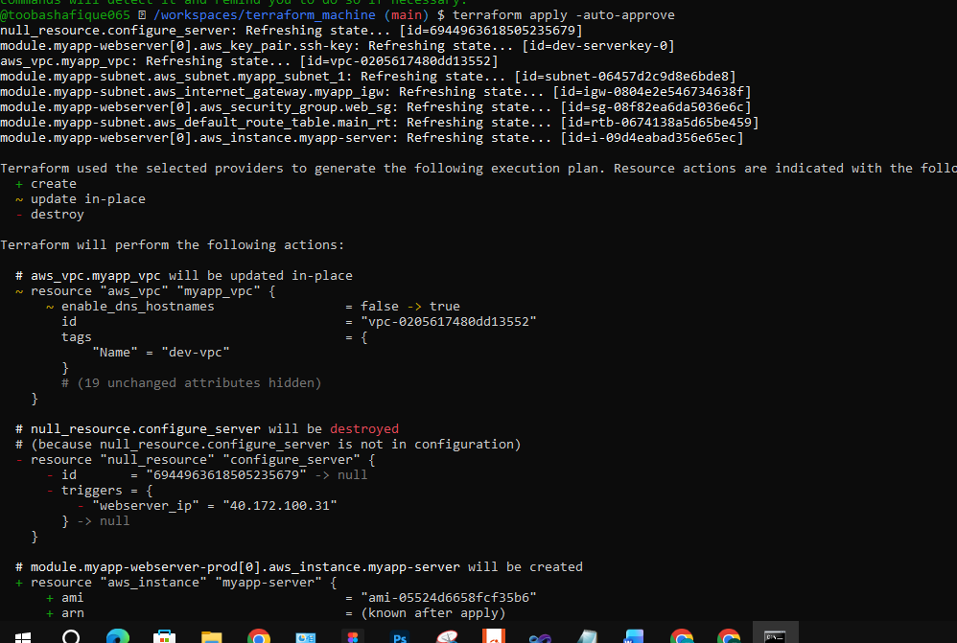
- task11_terraform_output_dynamic_ips.png
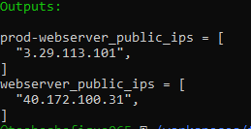
- task11_boto_install.png
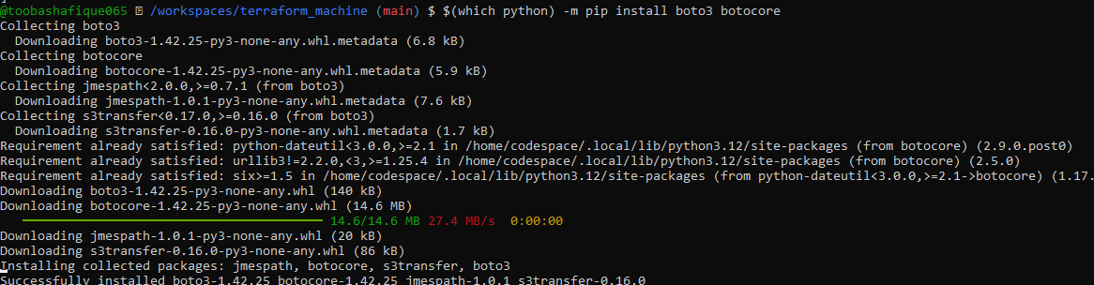
- task11_boto_version.png
- task11_ansible_inventory_graph_initial.png
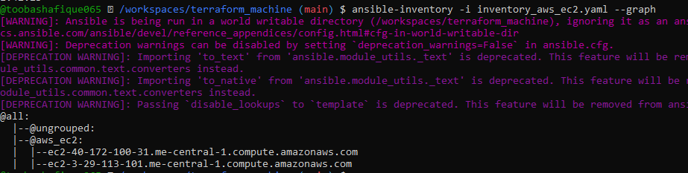

📌 Task 12 – Filtering by Tags & Instance Type
Tasks
- Group EC2s by tags and instance type
- Run Ansible on filtered groups
Screenshots
- task12_inventory_aws_ec2_tag_groups.png
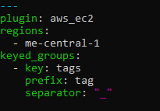
- task12_inventory_graph_tag_groups.png
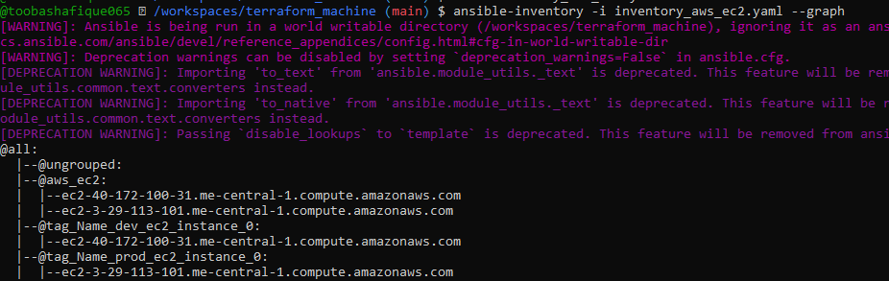
- task12_inventory_aws_ec2_instance_type_groups.png
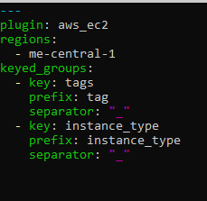
- task12_inventory_graph_full.png
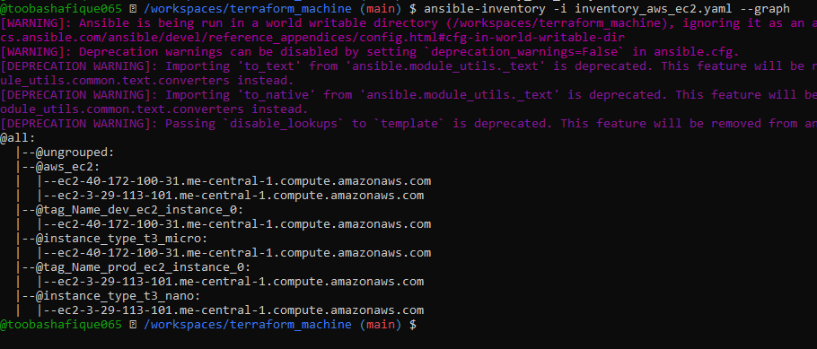
- task12_my_playbook_all_hosts.png
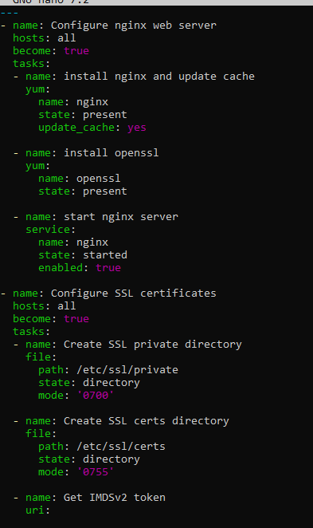
- task12_ansible_play_all.png
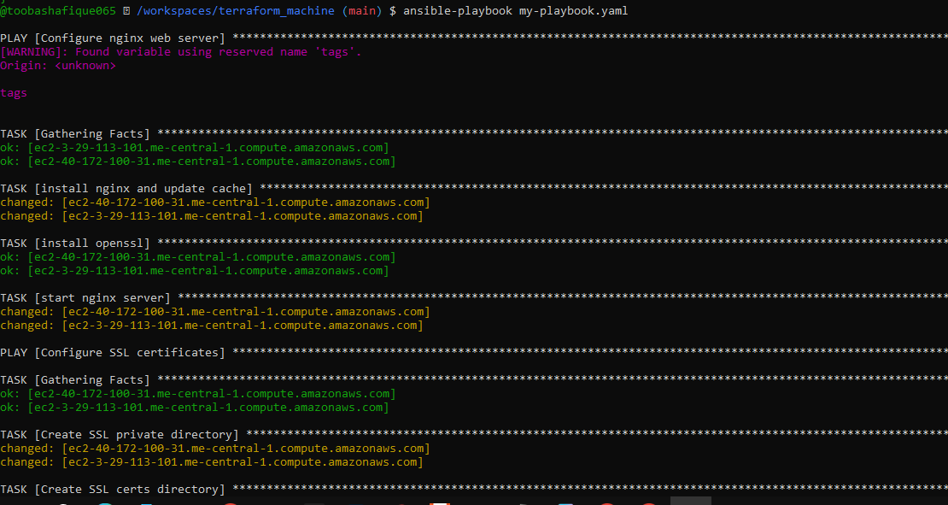
- task12_ansible_play_dev_only.png
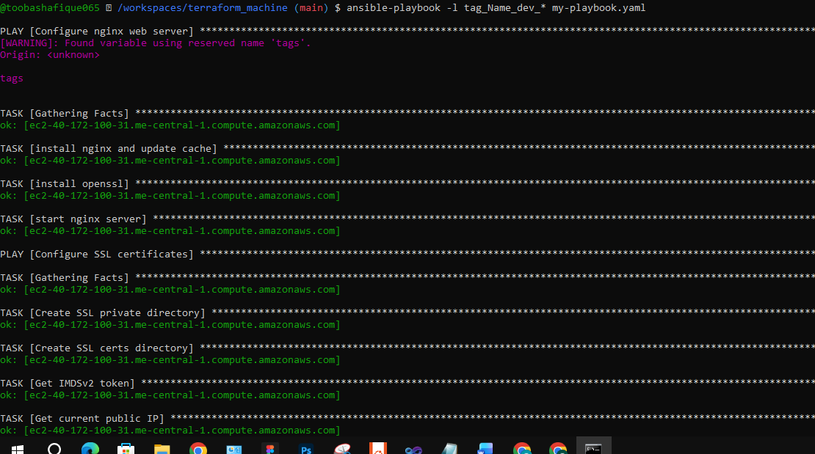
- task12_ansible_play_prod_only.png
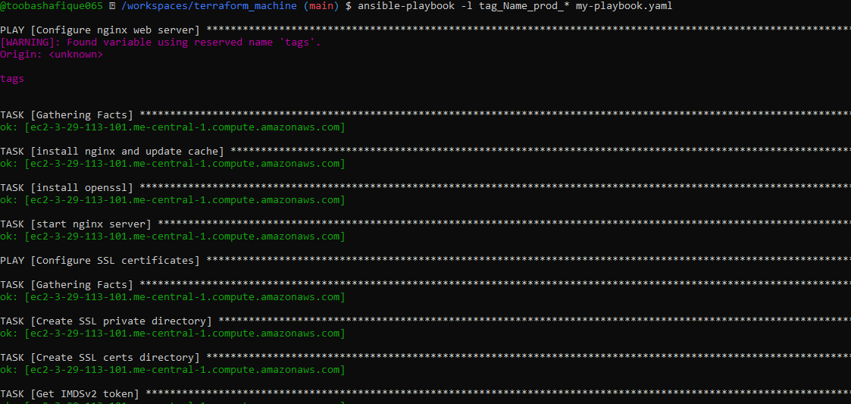
- task12_ansible_play_t3_micro.png
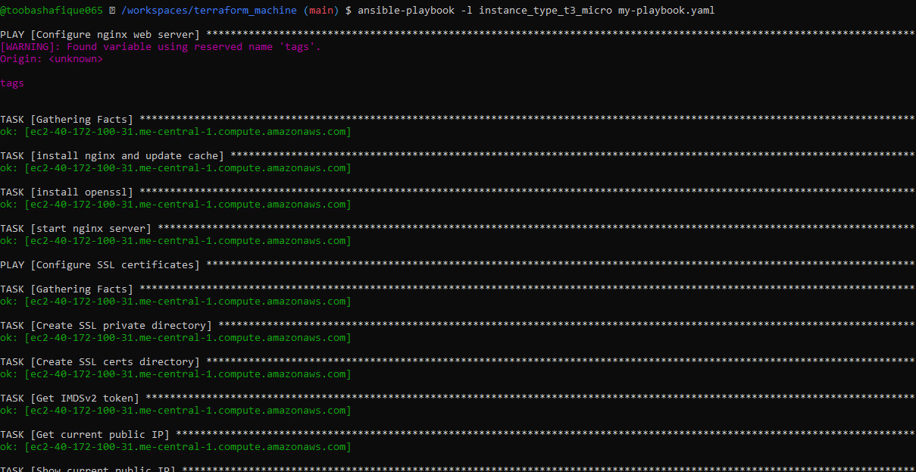
- task12_ansible_play_t3_nano.png
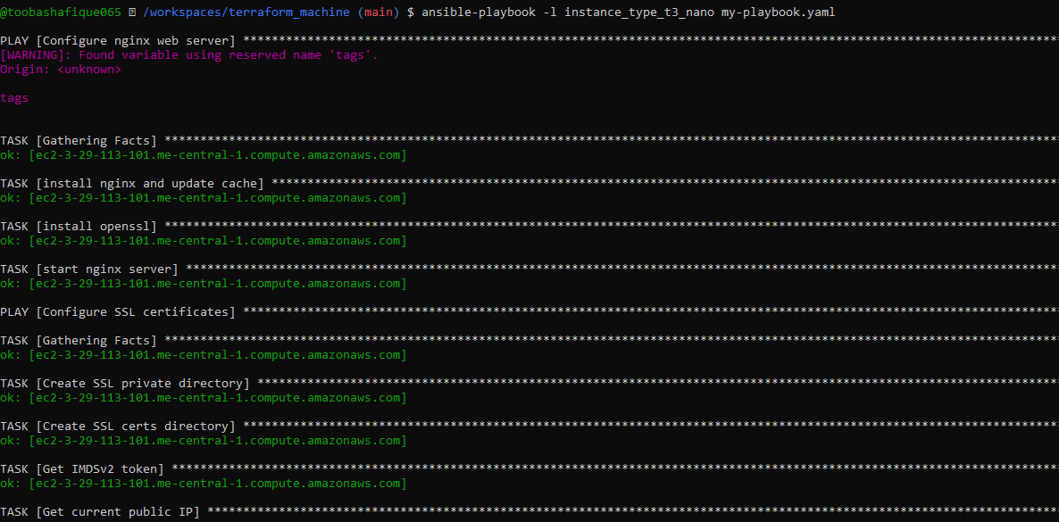
- task12_ansible_cfg_inventory_default.png
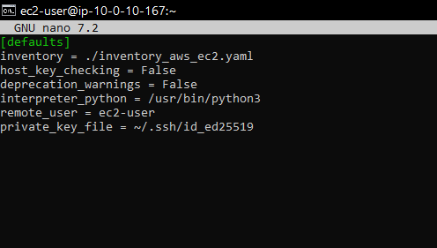
- task12_ansible_play_t3_nano_no_i.png
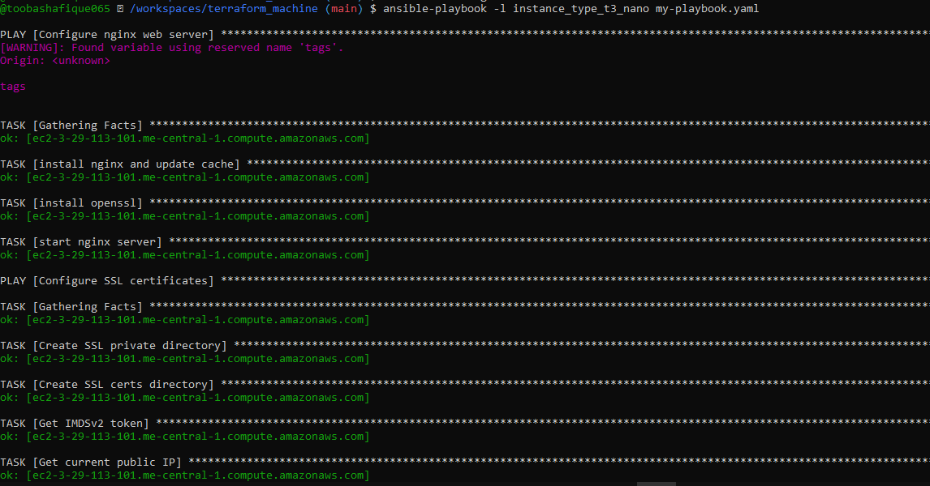

📌 Task 13 – Ansible Roles (nginx, ssl, webapp)
Tasks
- Create Ansible roles
- Convert playbooks to role-based
- Deploy nginx, SSL & webapp using roles
Screenshots
- task13_main_tf_single_dev.png
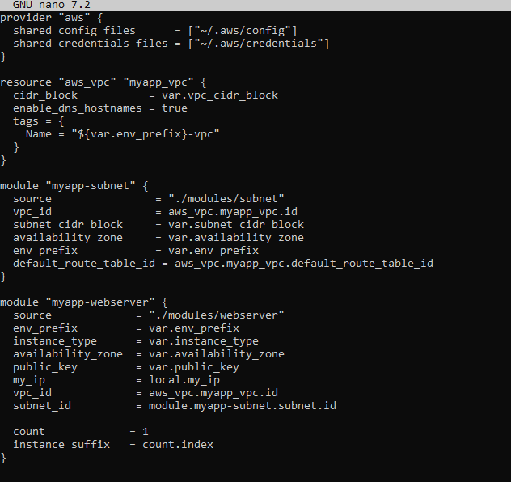
- task13_ansible_structure_created.png
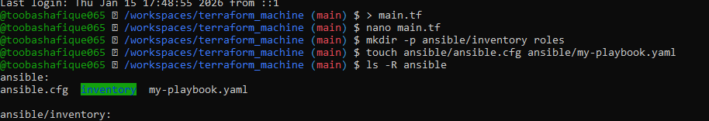
- task13_ansible_cfg_project.png
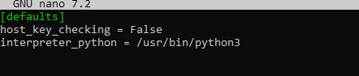
- task13_ansible_inventory_hosts.png
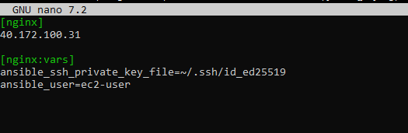
- task13_roles_created.png
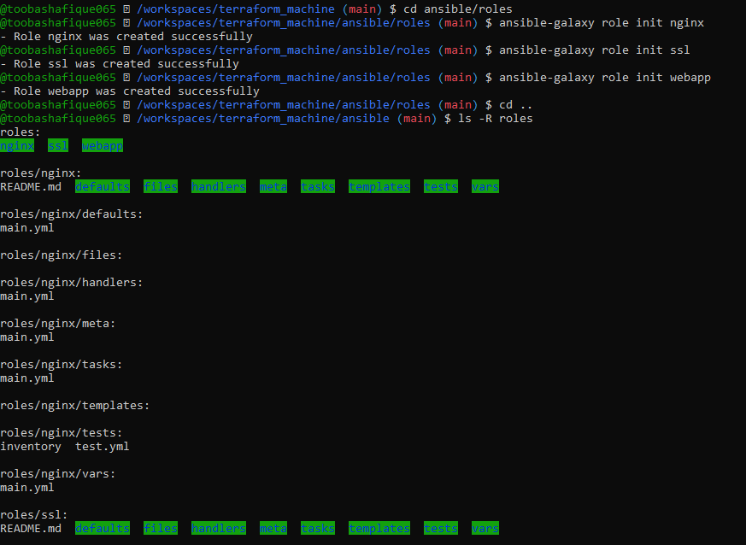
- task13_nginx_handlers_main.png
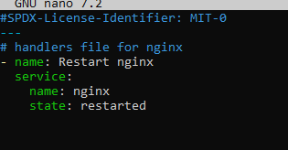
- task13_nginx_tasks_main.png
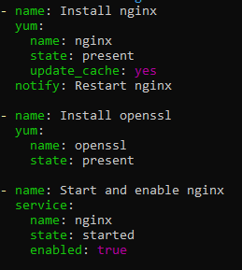
- task13_my_playbook_nginx_only.png
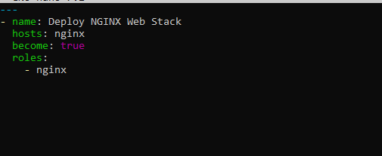
- task13_ansible_play_nginx_only.png
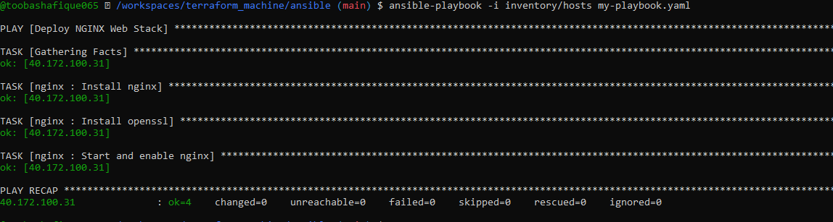
- task13_nginx_browser_roles.png
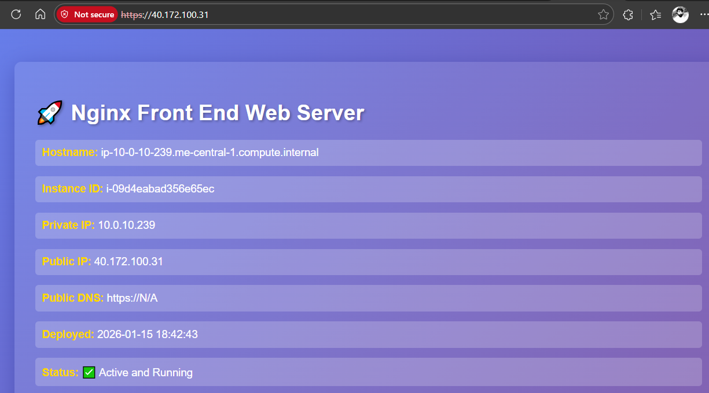
- task13_ssl_defaults_main.png
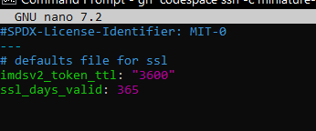
- task13_ssl_tasks_main.png
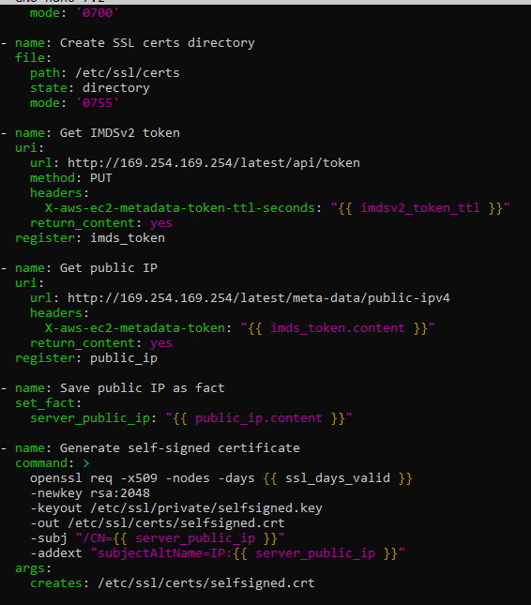
- task13_webapp_defaults_main.png
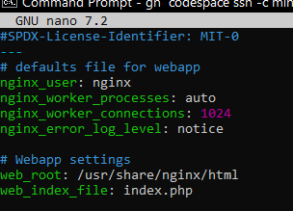

- task13_webapp_files_index_php.png
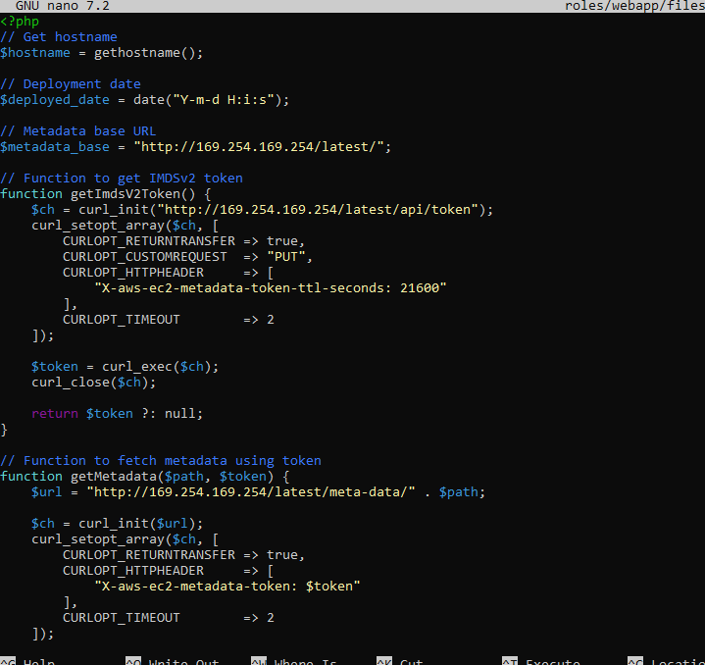
- task13_webapp_handlers_main.png
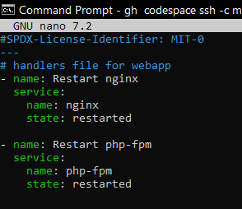
- task13_webapp_templates_nginx_conf.png
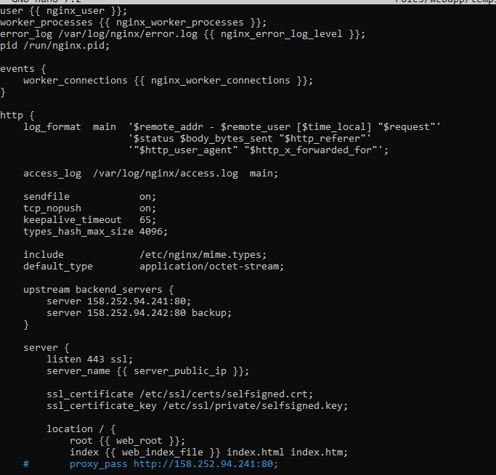
- task13_webapp_tasks_main.png
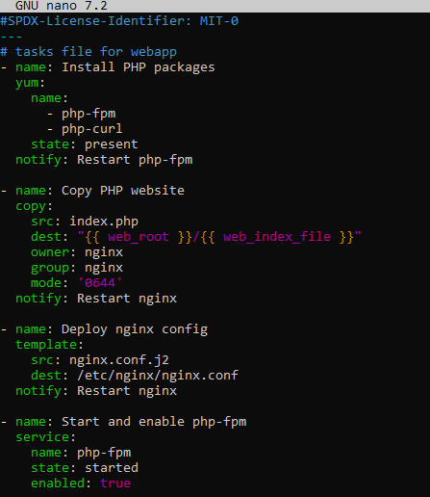
- task13_my_playbook_roles_full.png
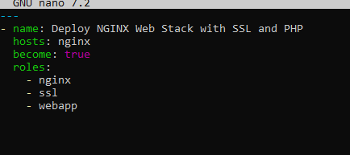
- task13_ansible_play_roles_full.png
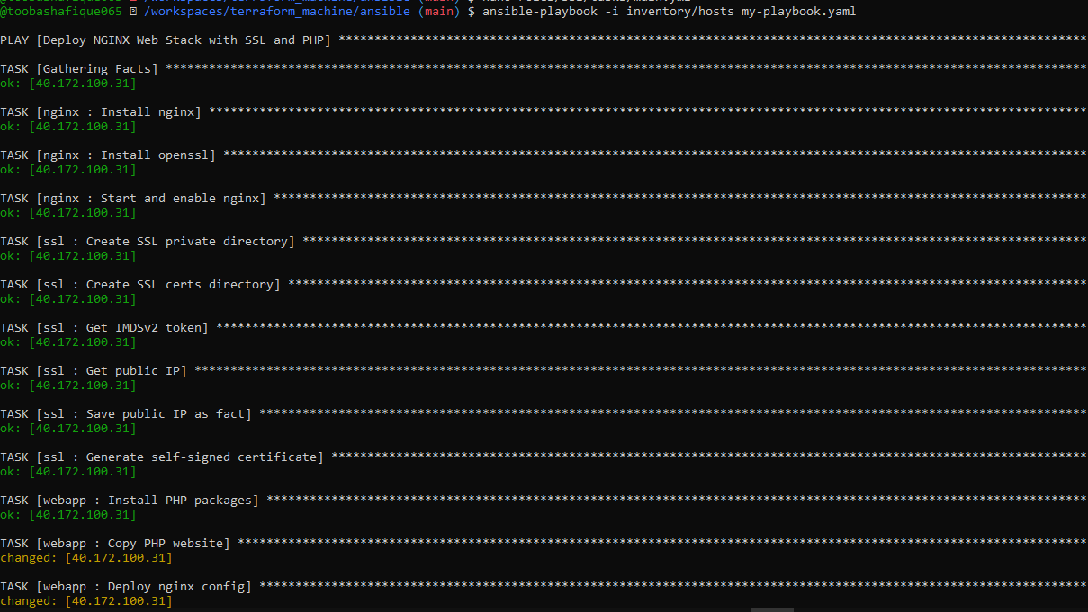
- task13_php_https_browser_roles.png
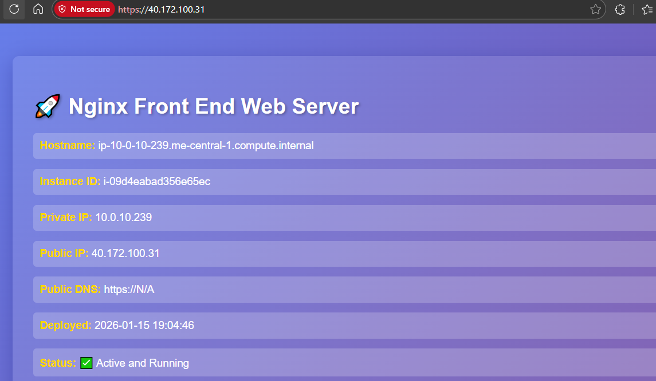
Cleanup:
- cleanup_terraform_destroy.png
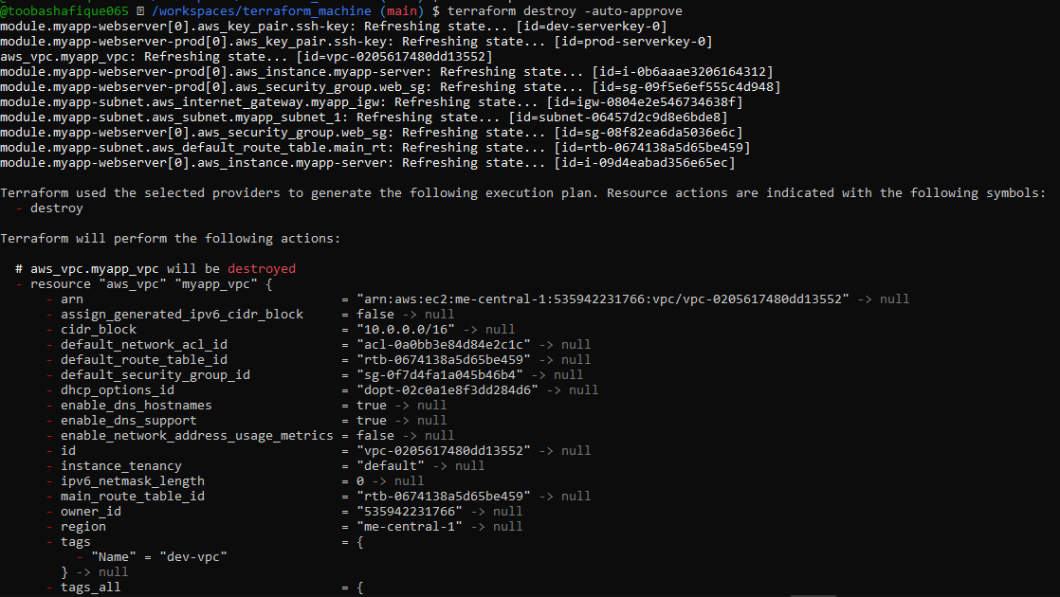
- cleanup_tfstate.png
